**LAB SESSION # 07**

* **16*1 MULTIPLEXER CIRCUIT DIAGRAM :**

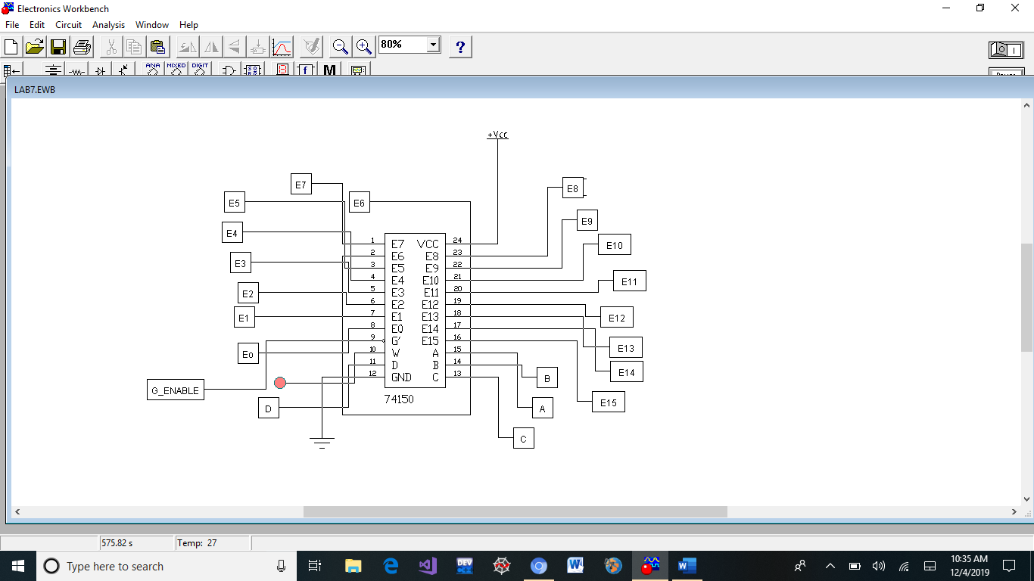

* **SUB CIRCUITS:**

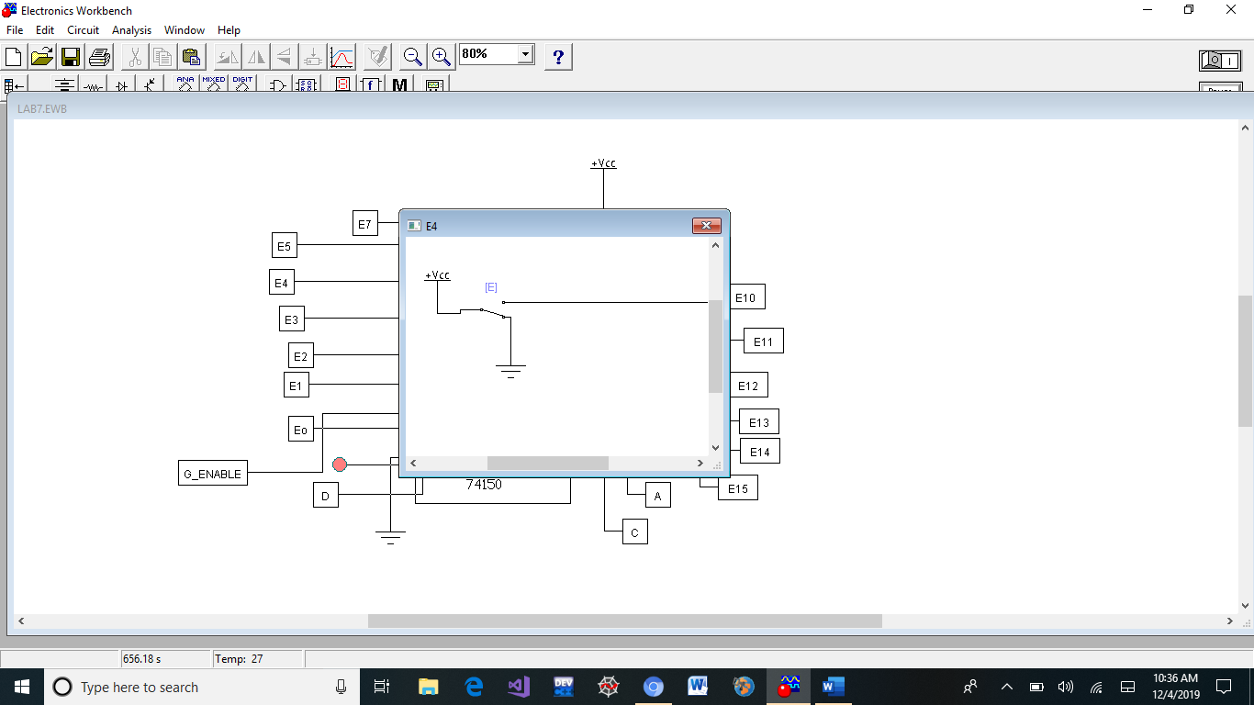

* **Prepared by Muhammad Faraz Ansar (SE-061)**